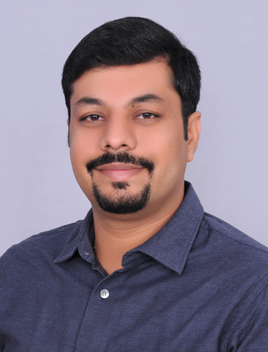

RUDRAKSH GARG
Sales & Marketing | Business Development | Channel Management

rudraksh_raj1985@yahoo.co.in
rudrakshraj1985@gmail.com +91-9212363553
+91-9540948481
MBA (Marketing & International Business) with nearly 9 years of rich experience in sales, business development and client relationship management; targeting challenging assignments with an organization of repute

Executive Profile  - Expertise in augmenting business, penetrating new markets, introducing new products, managing territory & product channel sales & promotional plans, directing shipments by utilizing strong business, technical & commercial acumen  - Hands-on experience in networking with clients, identifying their requirements, proposing effective solution, resolving their complaints, thereby enhancing customer base  - Rich exposure in identifying & adopting emerging trends and addressing industry requirements to achieve organizational objectives by tracking latest marketing trends and competitors’ moves  - Excellent at enhancing market share of the organization by establishing strategic alliances and tie-ups with retailers and distributors  - Managed business to the tune of over INR 78 crores annually across South Delhi region  - Experienced in exceeding targeted sales goals, developing profitable & productive business relationships and building an extensive client base, capable of accomplishing multi-fold revenue increase  - An out-of-the-box thinker with a flair for charting out marketing & promotional strategies and contributing towards enhancing business volumes & growth and achieving profitability norms  Education & Credentials  - MBA (Marketing & International Business) from Kohinoor Business School in 2010 with First Class  - BE (Food Technology) from Rajasthan University in 2007 with First Class | Key Impact Areas  Soft Skills
  Sales & Marketing
  Business Development
  Strategic Account Management
  Channel/ Distribution Management
  Marketing/ Promotional Campaigns
  Product Presentations/ Demos
  Team Management
  Team Player
  Interpersonal
  Flexible
  Analytical
Career Timeline
Atlanta Elevators (I) Pvt. Ltd. as Business Development Officer
Shree Cement Ltd., Delhi as Management Trainee
Shree Cement Ltd., Delhi as Sr. Officer


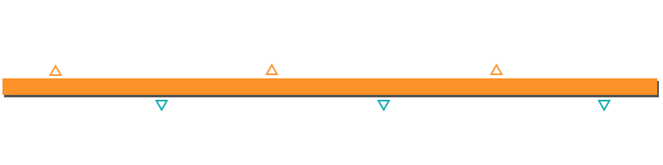
2010-2011

2011-2013

2013-2015

2015-2017

Since 2017

RCM as Quality Officer
Shree Cement Ltd., Delhi as Marketing Officer
Shree Cement Ltd., Delhi as Assistant Manager- Delhi
2009-2010


Selected Highlights & Contributions
- Managed sales turnover by over INR 6.5 crores
- On-boarded 20 dealers and received promotion from the company for the same
- Successfully grew the territory from 7500 metric tonne (MT) to 11000 MT
- Developed relationships with channel partners to drive sales of Grey Cement through their customer base

Organizational Experience

November 2011 till date: Shree Cement Ltd.
Currently managing sales of company’s Grey Cement in the assigned territory in coordination with dealers & retailers

Role:
- Driving business growth through identification of new market segments for attainment of targets with a view to optimize revenue
- Initiating and developing relationships with key decision-makers in target organizations for business development
- Promoting & marketing a portfolio of products by organizing events & seminars
- Prospecting, identifying and establishing new clients in the assigned region
- Administering a portfolio of dealers & retailers and devising sales strategy, targets, schemes with them
- Establishing relations with existing dealers network and devising plans to on-board new dealers & retailers
- Managing customer relationship, ensuring timely delivery of materials in coordination with transporters, attending customer complaints and resolving their concerns
- Maintaining awareness of latest trends in the market; organizing consumer visits and performing competitors analysis and updating the management
- Reporting on targets v/s achievement in the company ERP along with action plan for the next month
- Organizing mason meets and delivering proper guidance to masons, builders, contractors on various products

Previous Experience

June 2010 – November 2011: RCM as Quality Officer

Highlights:
- Steered competitor/market analysis to get a fair idea of the latest market trends and the competitor moves ahead to achieve market share metrics
- Built healthy business relations with clients & external associates for securing repeat business & long-term loyalty
- Managed production and performed cost analysis to increase the profit of the organization
- Designated as Project Head of Namkeen Plant; managed functions such as purchase, quality check, raw materials
- Evaluated quality of food products of various companies, namely Namkeen, Biscuits, Papad and many other eatables

December 2009 – May 2010: Atlanta Elevators (I) Pvt. Ltd. as Business Development Officer

Highlights:
- Successfully managed lead generation, follow-ups and assisted the customers in achieving budgetary target
- Gathered data & shared trade information, competitor's activities and market intelligence information to the management for decision-making
- Executed & implemented business plans; penetrated into new territories
- Organized pre & post marketing activities to spread awareness of new products to customers
- Led sales promotion activities like publicity campaigns for enhancing awareness & visibility as part of market development effort
- Developed excellent relations with clients to generate avenues for additional business
- Enhanced business in the assigned area and led seamless sales & marketing activities to achieve the assigned targets
- Achieved sustainable market share by conducting detailed analysis of competitor brand
Extracurricular Activities
- Won inter-college competition in AD MAD Competition

Seminar/ Workshops
- Attended national seminar on Indian Dairy & Food Industry- Future Roadmap for Sustainable Growth at NDRI Karnal
- Took part in workshop conducted by Achal Rangaswamy on “Marketing Intelligence”


Personal Details
Date of Birth: 17th June 1985
Languages Known: English and Hindi
Present Address: 125, Gali No. 4, Chattarpur 60 Feet Road, Chattarpur, New Delhi-110074
Permanent Address: 345 I Azad Nagar, Behind Dalda Mill, Bhilwara-311001, Rajasthan
Alternate Number: 9829047191

